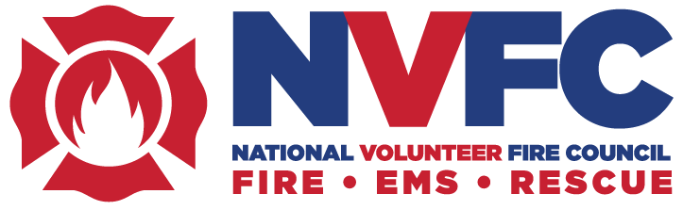

NVFC Board of Directors Holds Fall Conference in Rapid City, SD

The National Volunteer Fire Council (NVFC) Board of Directors held its annual Fall Conference in Rapid City, SD, on September 22-24, 2025. The board is comprised of up to two directors from 48 state associations and meets as a whole twice a year to conduct Council business and discuss matters of importance to the volunteer fire and emergency services. Among those in attendance were 60 directors from 39 states, including Chiefs Kevin Quinn & Mark St. Pierre from Rhode Island.

During the conference, the board discussed the status of the proposed OSHA Emergency Response Standard and next steps, as well as approved the framework of the organization’s five-year strategic plan. The board also received updates on NVFC projects, partnerships, and initiatives and reviewed proposed changes to the organization’s bylaws. The National Institute for Occupational Safety and Health recognized the NVFC as a National Firefighter Registry champion for the Council’s partnership and support of the Registry.

Several committees met to tackle critical issues impacting the NVFC and the nation’s volunteer fire and emergency services, including health, safety, and training; recruitment and retention; legislative; standards and codes; wildland; and more. In addition, the EMS/Rescue Section held its biannual meeting. Chief Quinn currently serves on the Health, Safety, & Training Committee, Standards & Codes Committee, and the Legislative Committee. Chief St. Pierre also serves on the Legislative Committee as well as the Volunteer Advocacy Committee & By-laws Committee.

Along with the business side of the meeting, the board enjoyed a welcome social hosted by the South Dakota Firefighters Association (SDFA); the Chair’s Lunch cosponsored by Clarion Fire Group and Wendell’s Mint; a dinner hosted by SDFA and Pennington County Fire Services; a networking breakfast sponsored by FirstNet, Built with AT&T; a networking lunch sponsored by OnStar; continental breakfasts sponsored by Tesla, NFPA, and Provident; and breaks sponsored by Columbia Southern University and the Anheuser-Busch Foundation. An auction, sponsored by ESIP, raised over $4,800 for the NVFC’s Health and Safety Fund. There was also a rehab unit demonstration from the South Dakota Auxiliary.

The NVFC appreciates the support and hospitality of our hosts, the South Dakota Firefighters Association and Pennington County Fire Services. Thank you to our conference sponsors: Anheuser-Busch Foundation; Clarion Fire and Rescue Group; Columbia Southern University; ESIP; FirstNet, Built with AT&T; National Fire Protection Association; National Hero Plus Program; OnStar; Provident; Tesla; and Wendell’s Mint.

The NVFC’s Spring Conference will be held on May 15-17 in Alexandria, VA.

The NVFC is the leading nonprofit membership association representing the interests of the volunteer fire, EMS, and rescue services. The NVFC serves as the voice of the volunteer in the national arena and provides critical resources, programs, education, and advocacy for first responders across the nation. Learn more about the NVFC and join at www.nvfc.org.

